INS3121
SOIL MECHANICS
FINAL EXAM
January 6, 2017

Student Name Surname:
Q.1/20p | Q.2/30p | Q.3/25p | Q.4/25p | TOTAL
Number:
Group:

- Grain-size distribution curves of two type of soil are given in the below figure,
- Calculate the uniformity coefficient (C_{u}) and the coefficient of gradation (C_{c}) of the soils (4p).
- Define whether of two soils are given is well-graded or poor-graded soil (4p).
- Classify the soils according to Unified Soil Classification System (USCS) and American Association of State Highway and Transportation Officials (AASHTO) Classification System (8p).
- Which one of the soil can be used as a subgrade material in a highway construction (4p).?
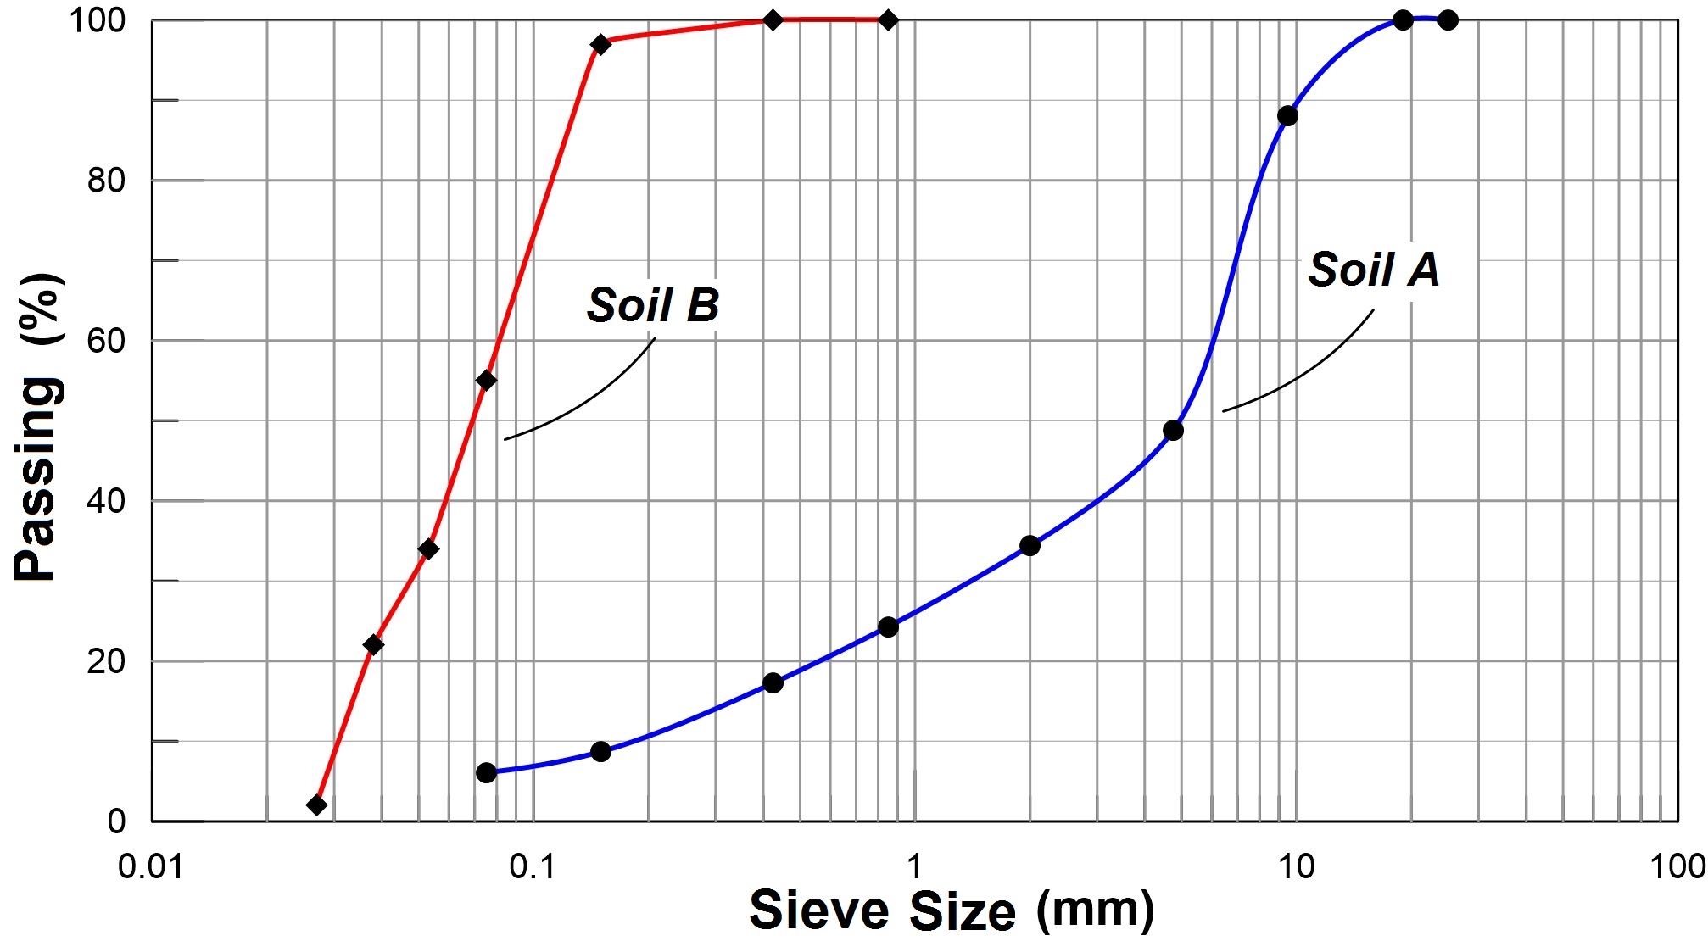
 | % Passing
Sieve No | Soil  A | Soil  B
4 | 48.8 | -
10 | 34.4 | -
20 | 24.3 | -
40 | 17.3 | 100
100 | 8.7 | 97
200 | 6.1 | 55
LL (%) | 40 | 48
PL (%) | 30 | 27

- An embankment of 1.5 m high is to be constructed over a soil profile shown in figure. A falling head permeability test was conducted on the cylindrical clay sample in order to define field permeability property of the soil. Falling of the water level in the standpipe from h₁ to h₂ took 63 hours. Properties of the permeability test are shown in Figure (a). 20 mm thick clay sample was recovered from clay soil and a consolidation test performed in the laboratory. The compression index of the clay (Cc) was found to be 0.146 according to the consolidation test results. Based on this information,
- Determine the permeability coefficient (k) of the clay soil (5p).
- What is the total settlement (δ_{c}) of the embankment? (Embankment covers a large surface in the field) (10p).
- Calculate the coefficient of volume compressibility (m_{v}) of clay layer. (δ_{c}= H. m_{v}. Δσ) (5p)
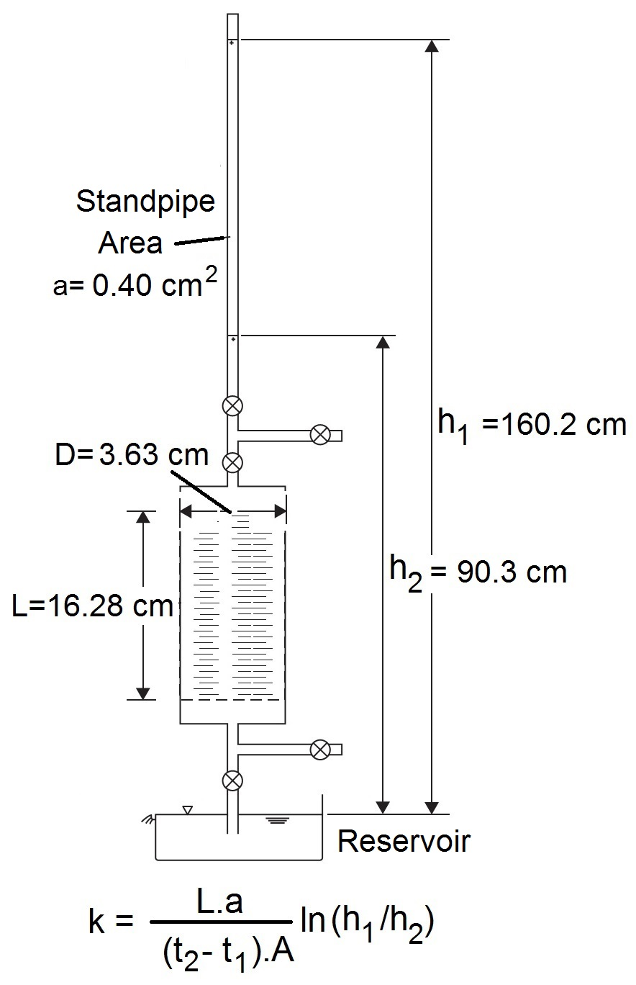
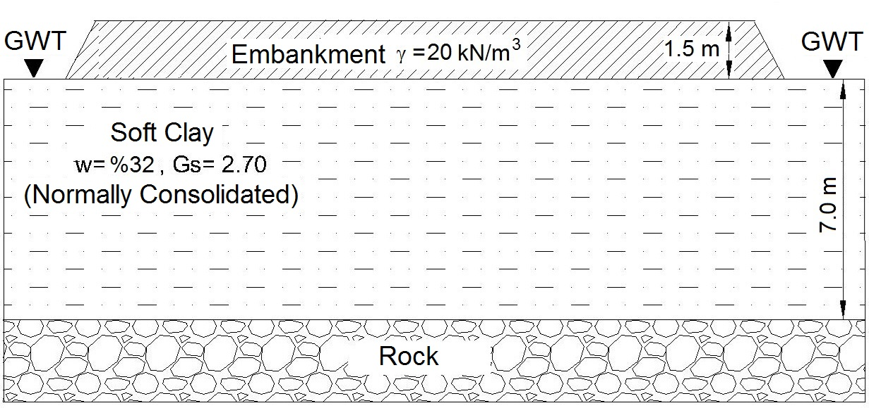
- Compute the time required for 60% consolidation of clay layer. (c_{v}=k/(m_{v}.γ_{w})). (T_{v}=0,287 for U=%60) (10p).
Figure (b)

Figure (a)

- The results of triaxial test performed undisturbed saturated clay soil samples are given in the below table;

Test Type | Cell Pressure (kPa) | Deviator Stress (kPa)
First CD Test | 50 | 84.4
Second CD Test | 150 | 134
UU Test | 100 | 50

a) Compute the drained shear strength parameters of the clay soil (10p).
b) Determine whether the soil is normally consolidated or overconsolidated clay according to the results obtained from the CD test (4p).
c) Compute the angle that the failure plane makes with respect to horizontal (4p).
d) Plot the Mohr Circle for the unconsolidated undrained test result and determine undrained shear strength parameters of the soil (7p).

- An earth fill will be constructed using sandy silt material. For the soil in borrow area, void ratio of the soil and specific gravity of soil solids were given as 0.95 and 2.70, respectively. Standart Proctor Test was conducted on the soil samples recovered from borrow area using a compaction mold which have volume of V= 9,439x10⁻⁴ m³ and different moisture content. Test results are given in the table below.
Wet (natural) weight (N) | 18.21 | 19.13 | 19.57 | 19.78 | 19.71 | 19.55
w (%) | 9 | 10.5 | 11.5 | 12.5 | 13.8 | 14.7

- Plot the compaction curve and determine the maximum dry unit weight and optimum moisture content of the soil (12p).
- Calculate how much minimum filler material is necessary for compacted fill of 180000 m³ that meets 95% relative compaction. (if you don’t find the answer in part a, consider γ_{dmax}=18.0 kN/m³ and w_{opt}= 12%) (8p).
- What is compaction, explain briefly. What are the factors that affect compaction in field? (5p).
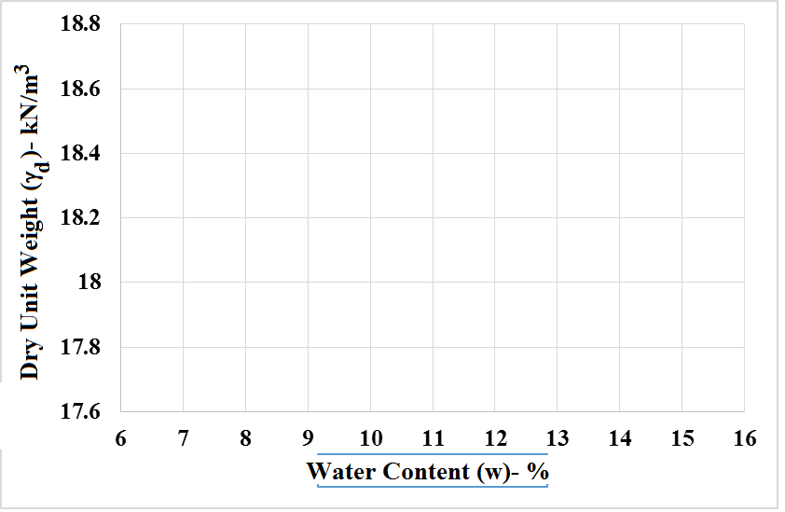

Time is 90 minutes. Good Luck…

